Instructions on how to apply on online competition database

Table of Contents

(Hold Ctrl key on the keyboard and click on the links below). | Page No.
Registering for the Competition. | 2-6
Uploading your application form | 7-8
Status Updates in the Workspace | 9
Submitting a Query to Human Resources Division | 10-11
Any problems | 12

Please Note: The screenshots in this instruction book are for example purposes only.
Registering for the Competition

Step 1

To take part in the competition, you must first log on to the jobs website (http://jobs.justice.ie). You will be presented with two options. The External Competitions link is for competitions open to members of the general public. The Internal Competitions link is for competitions open to staff of the Department only.

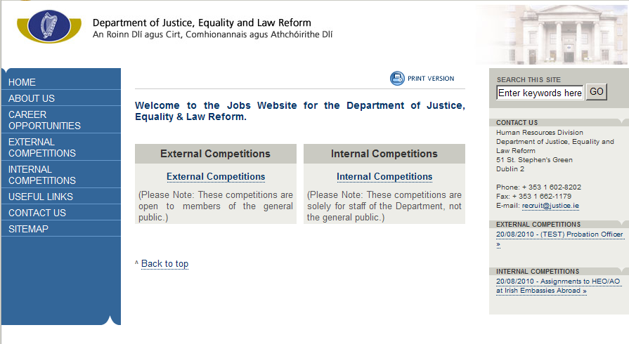

Step 2

Click on the link for Internal Competitions. You will then see a list of Department competitions currently being held and using the online database. The title of the competition will indicate the grade of the post in question. Select the competition you wish to apply for.

Registering for the Competition (cont.)

Step 3

Before you can register your details, you must first enter the competition password in the field on the bottom left of the screen. This password (case-sensitive) will be provided in the Office Notice for the competition. When you register your personal details, and choose your unique username and password, you will not have to enter the competition password again. You can login directly by entering these details in the 'Registered Users' field on the right of the screen.

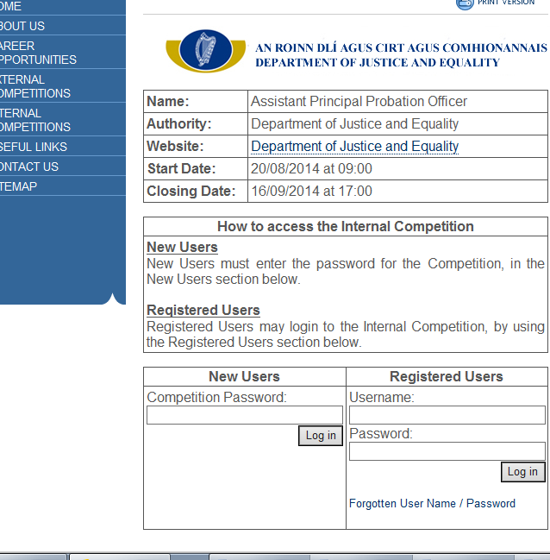
Registering for the Competition (cont.)

Step 4

When you enter the competition password correctly, you will see a screen similar to the following (scroll to bottom of page). You will see a copy of the Office Notice and the application form for the competition. The link to register will now be visible.
Click on the 'Register' button.

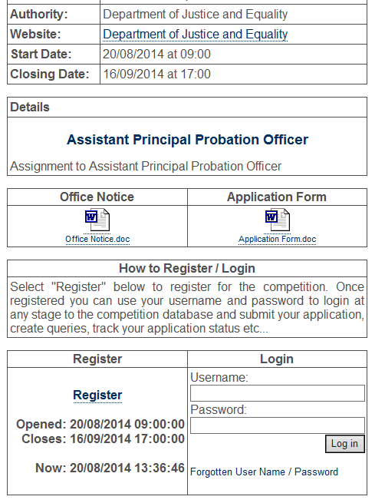

Registering for the Competition (cont.)

Step 5

Enter your details on the registration form. Please take note of your username and password as you will need it to log in during the course of the competition. The password must be 8 characters made up of both letters and at least 1 number. Please ensure that you enter your contact details in the manner indicated. e.g. The mobile number is broken into 3 fields: 00353 87 1234567. Please ensure that these details are entered correctly.

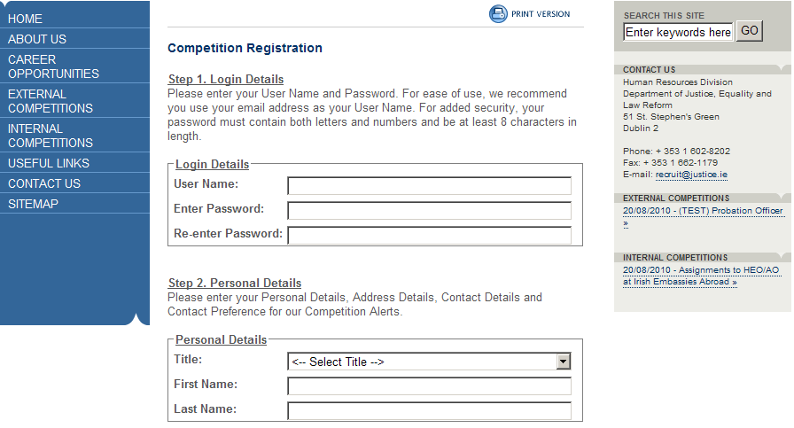
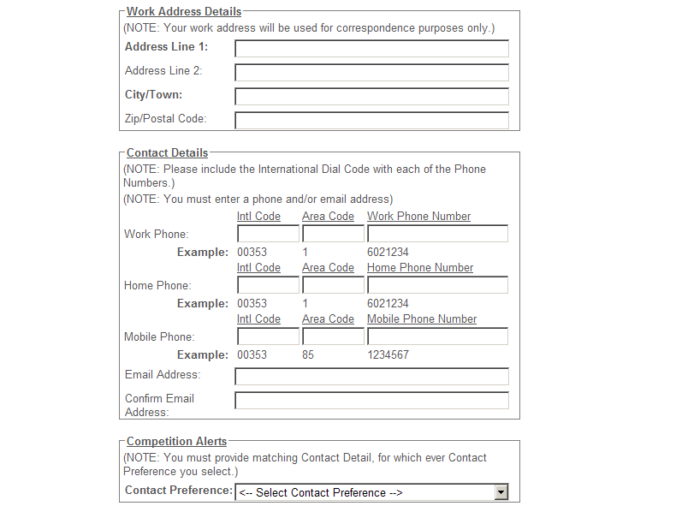

Registering for the Competition (cont.)

Step 6

When you enter all information correctly on the registration form, you will see the following screen telling you that you have entered all your information correctly. It will show your Unique Application ID (the one given below is an example). Click on 'View My Application' at the bottom of the screen to continue.

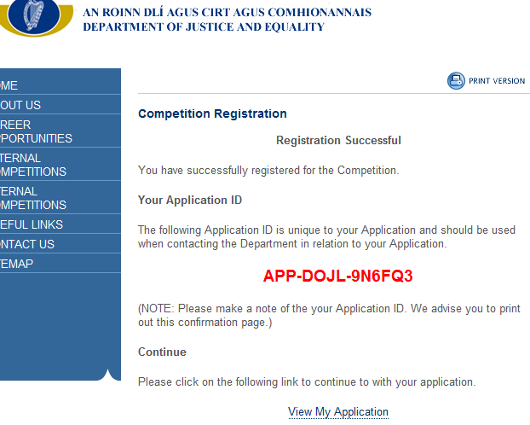

Uploading your application form

Step 7

You will need to prepare your application form on your own computer. When you are finished preparing this document, you should click on the 'Browse' button and select the file from the location you have saved it.

When the filename is displayed, click the 'Upload' button. Once you upload this document you will not be able to edit it further. You will be able to see the file that you uploaded from your Workspace (see sample screenshot on next page).

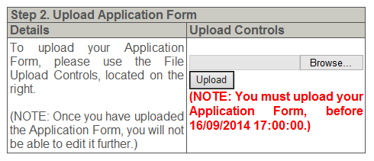

Uploading your application form (cont.)

Step 8

When you upload this document, your workspace will display a message telling you that the document has been successfully uploaded. You can view your uploaded document by clicking on the blue link below the message box.
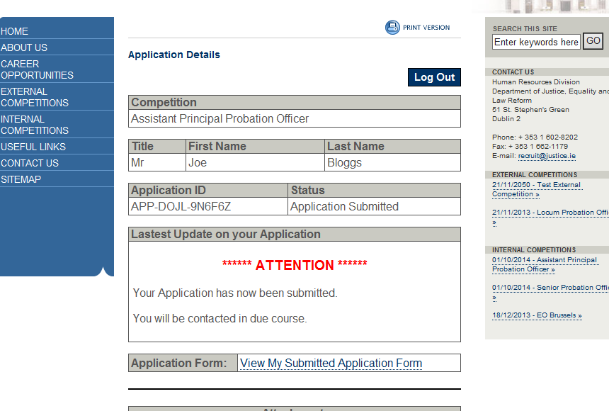

Status Updates in the Workspace

As the competition progresses, you will notice the message that appears in your Workspace will change accordingly. This will keep you informed of your progress throughout the competition up to and including the communication confirming whether or not you have been successful.

Example:
When you have successfully uploaded your application form a message similar to the one below will be displayed in your Workspace.
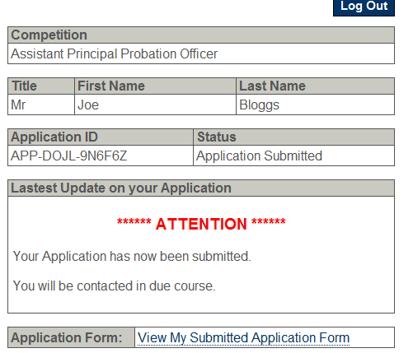

Submitting a Query to HR Division

Queries can be emailed to competitions@justice.ie.

Human Resources Division
September 2018

